Study Guide

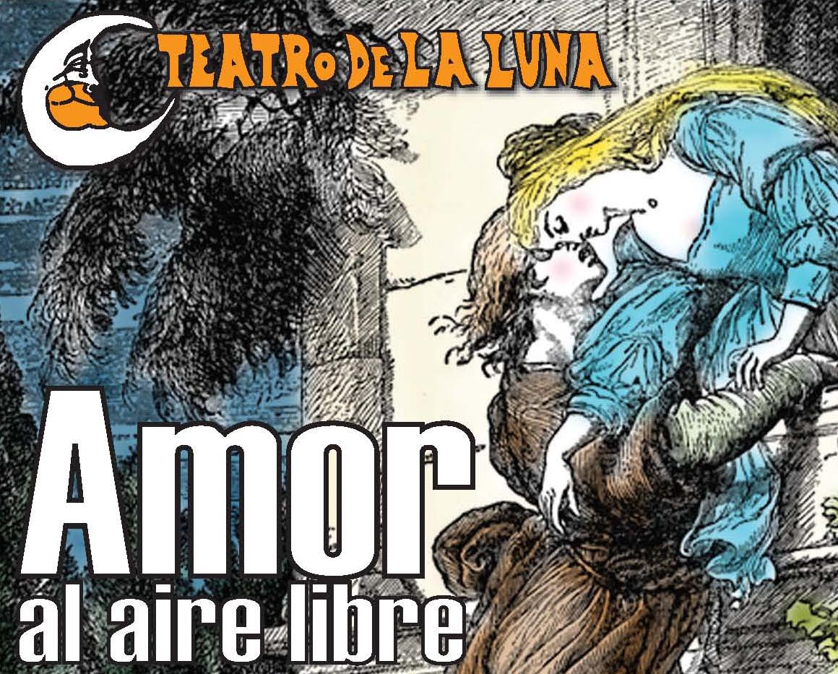

Amor al Aire Libre
(Love in the Open Air)
by Carlos Pais
Table of Contents

Spanish-English Vocabulary ………………………………………………………. 3

Common Sayings and Phrases …………………………………………………….. 4

Carlos Pais Biography …………………………………………………………….. 5

Geographical Places from the Play ………………………………………………... 6

Balconies of Buenos Aires ………………………………………………………… 7
Spanish-English Vocabulary

Words are translated in the sense of the play, rather than other possible meanings
Regionalisms and slang are marked with a *

A
abismo abyss
ablandar to mollify
afligir to trouble
agachar to stoop
agarrar take hold of
aguantar to withstand
agujero hole
alocado mad/wild
alzado elevated
ansiedades anxieties
aplastar to flatten
apoyar to lean on
arrepentirse to repent
arriesgar to risk
asilo asylum
asumir to assume
atar to tie up
azar chance/fate
B
baterista drummer
boleadoras lariat with balls
at one end
bolo hardened feces
boludo stupid
bombachas balloon trousers
C
capricho whim
careta mask
cajón* coffin
cambio over (radio talk)
carajo damn
cartelito sign
castaño chestnut
celda jail cell
clavito little nail
colchón mattress
colgado hanging
comprobar to verify
contraalmirante admiral
contradiciendo contradicting
cotidiano daily
un cualquiera a nobody
cualunque* a nobody
cucharita teaspoon
cuervo raven
CH
chacarera folk song
charla chitchat
chisme gossip
D
delirante delirious
depravado depraved
desarmar disarm
E
ejército army
embrujado bewitched
encamar to go in bed
encuestadora pollster
estornudar to sneeze
etapa phase
F
fango mud
fariña* bad seed
ferroviario railroad worker
fetichista fetishist
fifando having sex
flora intestinal microbes in gut
fracaso failure
frasquito small jar
G
gancho hook
gorra cap
gotas drops (medicine)
H
harta exhausted
hinchar to swell/inflate
hueco hollow
hondo deep
I
imprescindible essential
J
jalea jelly
joderse to be screwed
K
L
laburadora hard worker
ladrillo brick
letal deadly
laburante worker
libidinoso lustful
ligado tied to
liviana of little weight
logro achievement
LL
M
manicomio mental hospital
mareado sick
martillo hammer
martillazo hammer blow
mellizos twins
membrillo quince
metidas involved
mierda crap/shit
mina chick/girl
mocoso ignorant/worthless
morochito* a little colored
mudanza moving
mudar move to another home
mugrienta dirty/grimy
mujeriego womanizer
N
nalga buttock
negar to deny
negrita boldfaced
Ñ
O
obnubilado confused
P
palabrotas swearwords
palanquita switch
papelón embarassed
pariente relative
al pedo* unnecessary
pegajosa sticky
piola clever/interesting
pelotudo uselessness
perfoverificador inspector
perturbador disturber
piné recruitment physical
porquería* filth
portería janitor’s place
portero janitor
presagio omen
previsible foreseeable
puntillas needles
putilla little whore
Q
quemar to burn
R
Rajar* to leave
rastro* trace/sign
regar to water (plants)
relajar to relax
rendir to be defeated
rescatar to redeem
resfriar to chill
resucitó resurrected
resumir to sum up
reventar to blow up
roble oak
RR
S
sádica sadist
saquito cardigan sweater
sindicato union (syndicate)
soga rope
sobresaltos shocks
sublevar to rebel
T
tenedor de libros bookkeeper
tornillos screws
traficantes traders
tramposo crooked
triturador crushing machine
U
undir to sink
V
verduguear to harass
vidalita* sad Argentine
love song

Common Phrases and Sayings

A secas by itself
Un abismo sin medida A bottomless abyss
Cría cuervos To raise a mockingbird
De nalga viniste y de nalga seguís. You were a breach birth and you’re still difficult.
La Escuela de Mecánica torture chamber
Hacer un parétesis take a break
Hijo de puta bastard
Me hechás en cara. Throw it in my face
Me pone en los bordes… getting on my last nerve
Meter la pata Put your foot in it
Mujeres de la vida Experienced women
Nada que ver con… Nothing to do with…
No se descontrole Control yourself
Poneme la mano Dios mio God help me
La puta que lo parió. The whore who bore you.
El ultimo tranvía You lost your last friend
Vieja de mierda dirty old woman

Carlos Pais
Biography

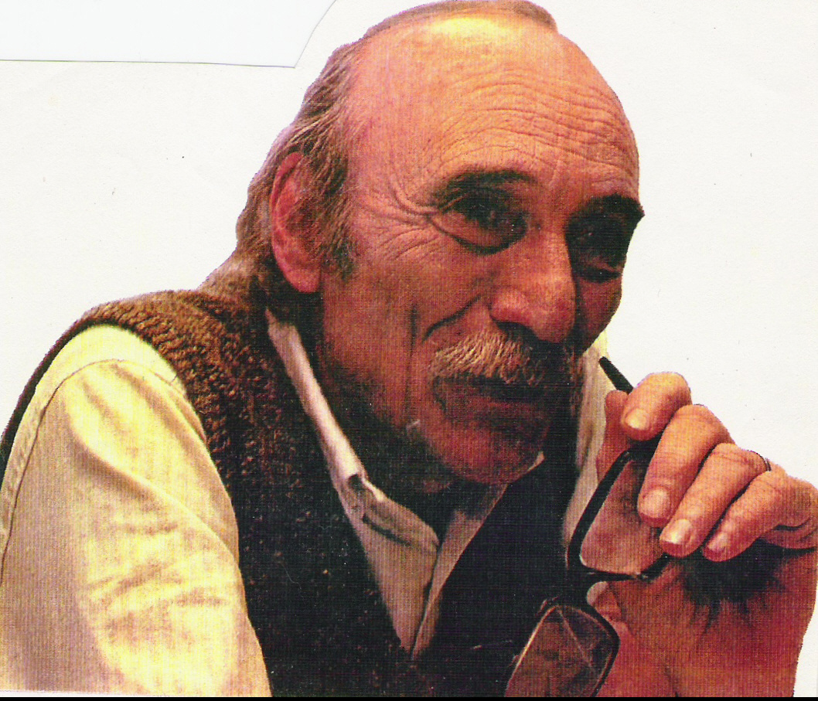
Carlos Pais was born in Santa Fé, Argentina in 1934. He studied law while simultaneously acting and directing. In 1962 he graduated from the School of Theater of Santa Fé Province and moved to Buenos Aires in 1964. His first play, Welcome los Amos (Welcome the Masters) premiered in 1972 and since then he has focused on playwrighting. As organizer and playwright he took part in the 1981, ’82, and ’83 “Teatro Abierto” (Open Theater) festivals. Over 20 of his plays have been produced, as well as published. They include La santa propiedad (Sanctified Property), Somos como somos (We Are as We Are), La oca (The Goose), Cuando me afeito (While Shaving), Extrañas figuras (Strange Figures), Noche de parias (Night of Pariahs), Las partes (The Parts), Maderas de Oriente (Oriental Woods), Soledad tango (Solitary Tango). With S. de Cecco and P. Mendez he wrote Moreira; with A. Torchelli El Hombrecito (The Little Man) and Che Madam; and with R. Cossa, R. Perinelli and M. de Gracia De cirujas, putas y suicidas (Of Cirujas, Whores and Suicides). Guachos, which opened in Buenos Aires' preeminent theater Teatro General San Martín in June 2005, is already being reprised this season. Multi-award winning, Pais' plays have also been staged in Uruguay, Cuba, Spain, the U.S. and Mexico. Pais is currently Vice Secretary of the General Society of Authors of Argentina.

Geographical Places from the Play

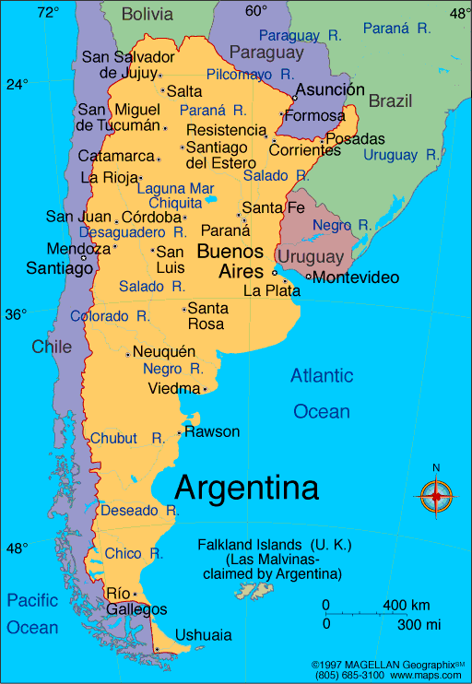

Provincia de Santa Fe

Totoras

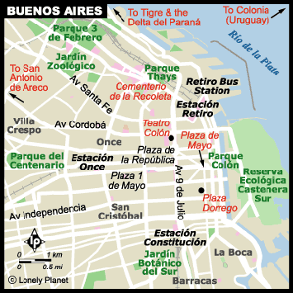

Recoleta

Junín (northwest of Buenos Aires)

Valdivieso
Balconies of Buenos Aires




